

**Cloud Deployment Models**

**Name:** Pratham Kandari

**Sap Id:** 500097663

**Batch:** 7

**LAB 7**

**Project Quota, Flavours, Usage Report**

Step 1: Open the openstack dashboard

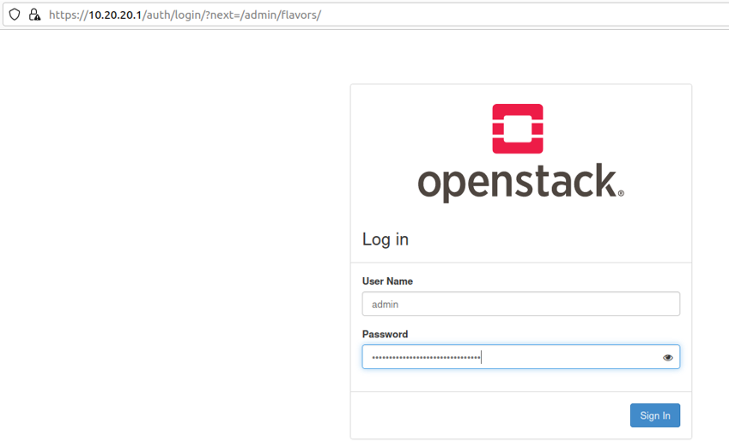

Step 2: Goto Admin-> compute -> flavors

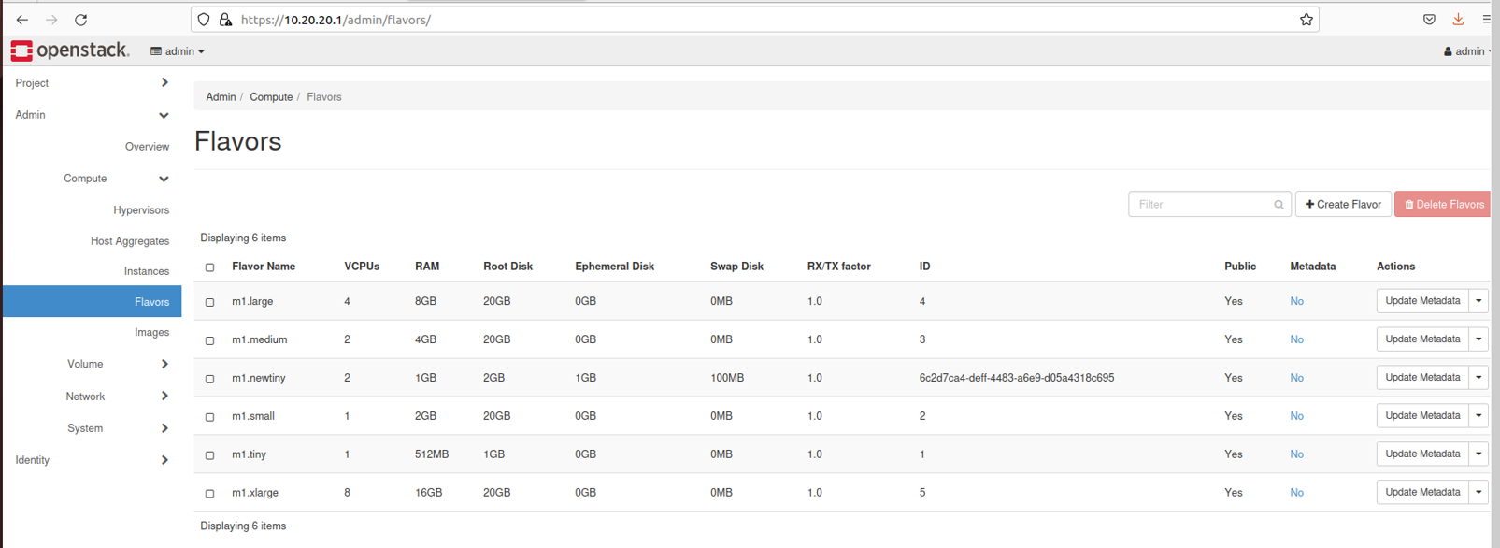

Step 3: Click on create flavor and provide appropriate configuration

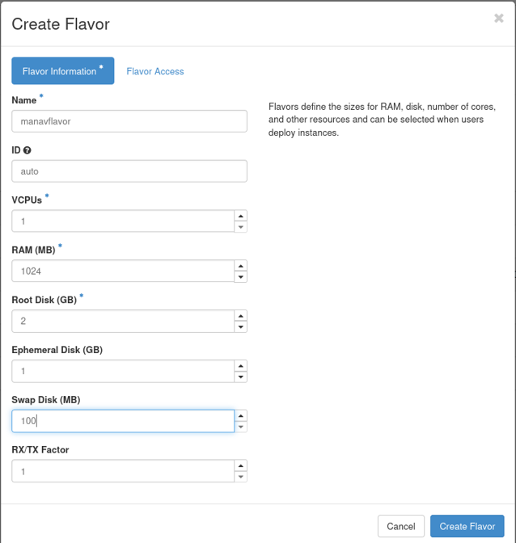

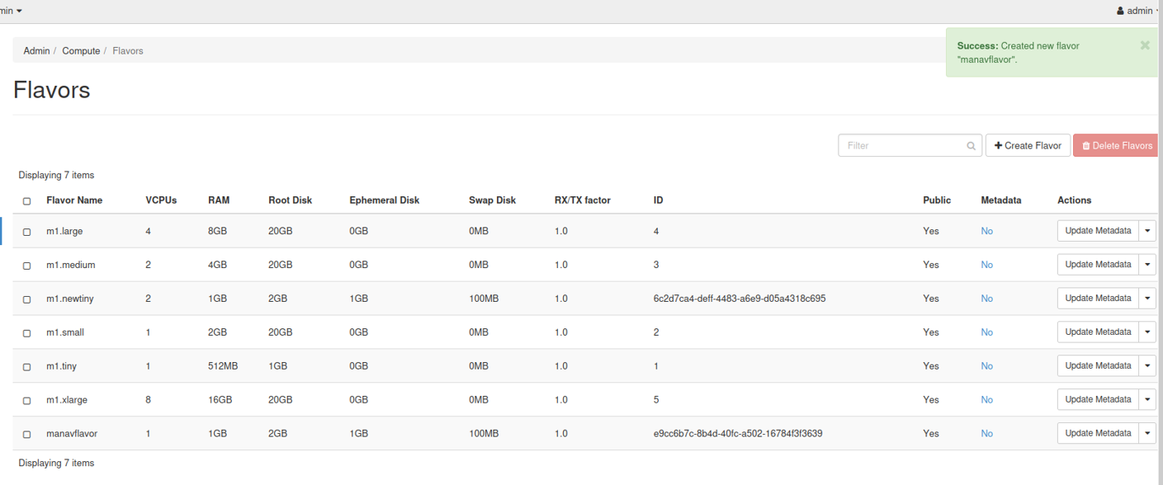

Step 4:- Goto Project -> Compute -> instances

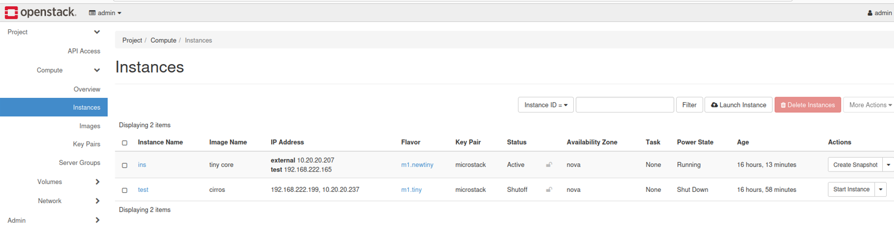

Step 5:- Click on create new instance and provide the configuration(select flavor created)

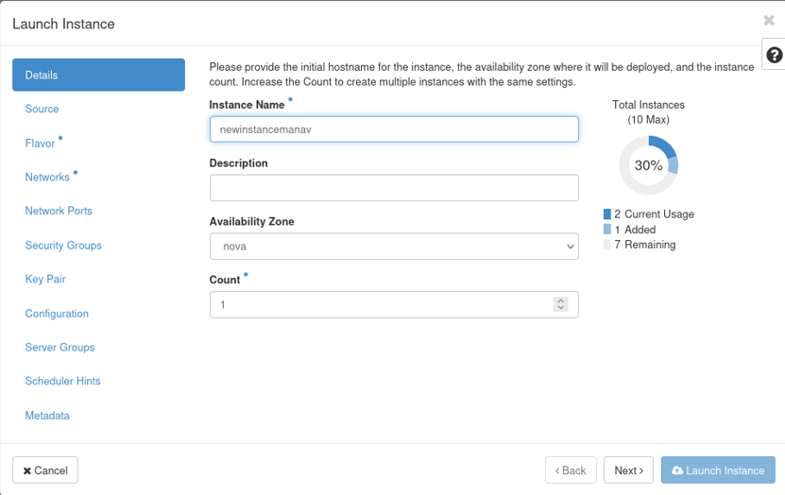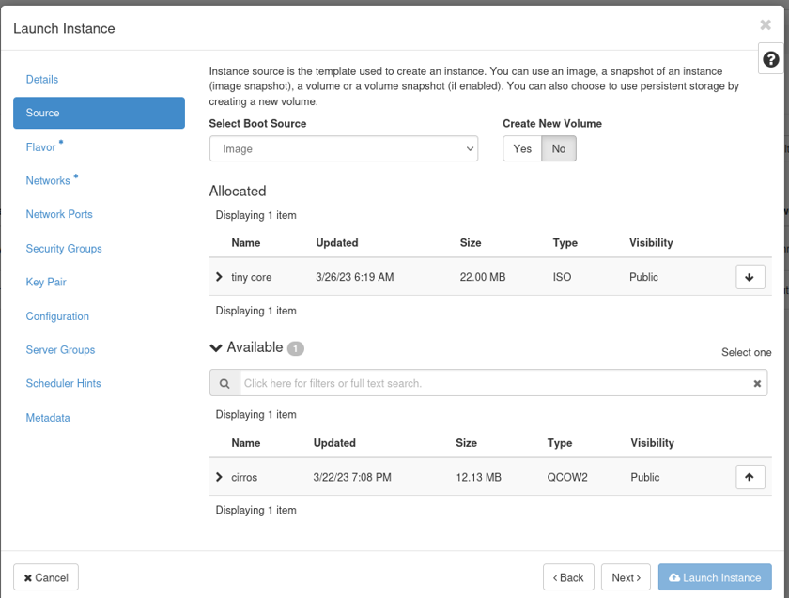

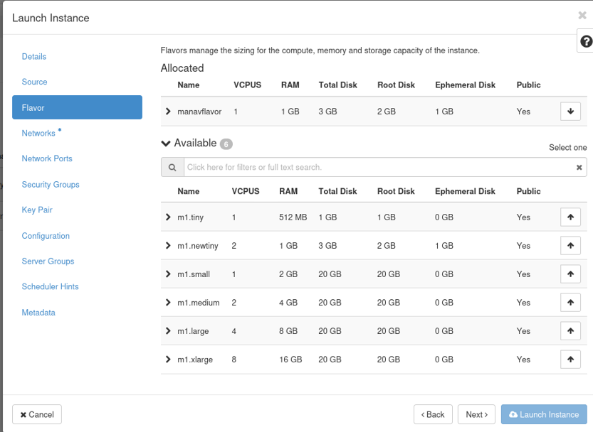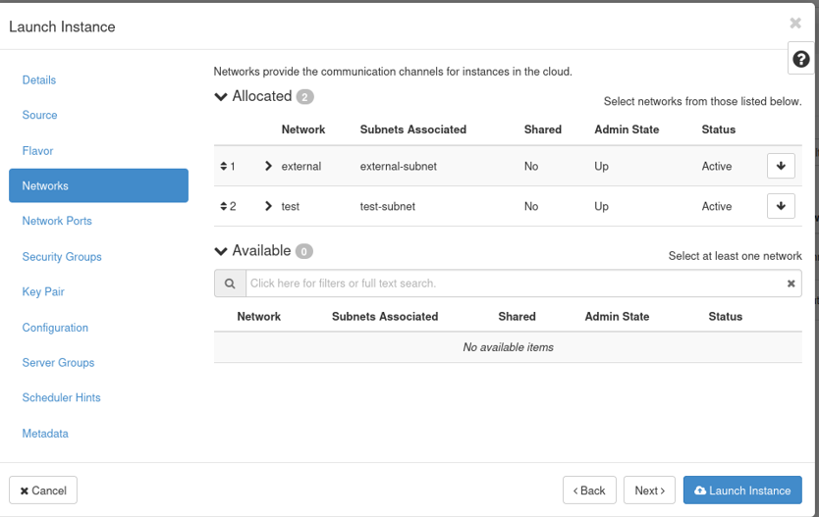

Step 6:- Click on launch instance to create instance with the new flavor

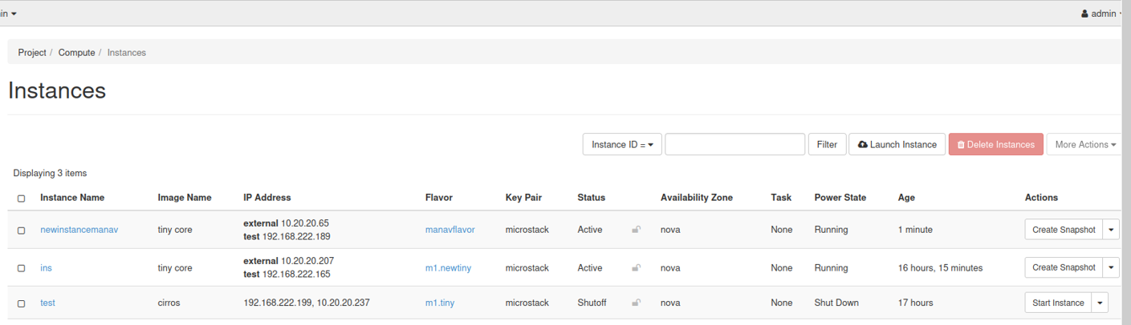

Step 7:- To modify the project quota & view usage we first launch instances via new proj

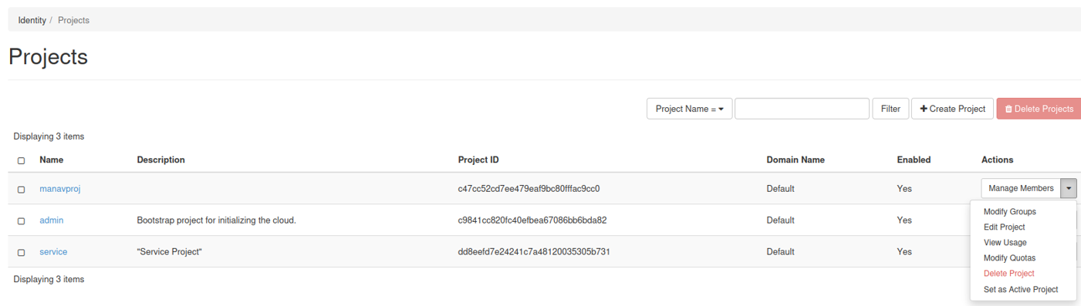

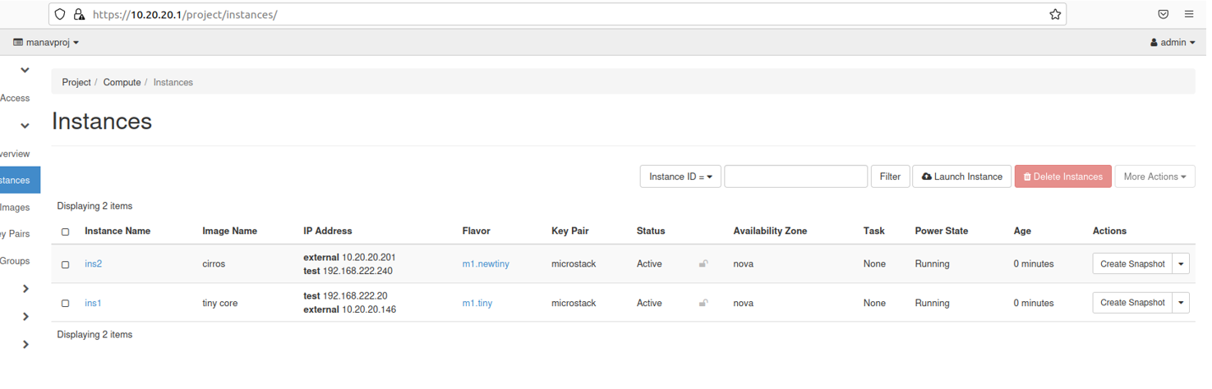

Step 8:- Open admin proj & goto Identity->Projects->View Usage

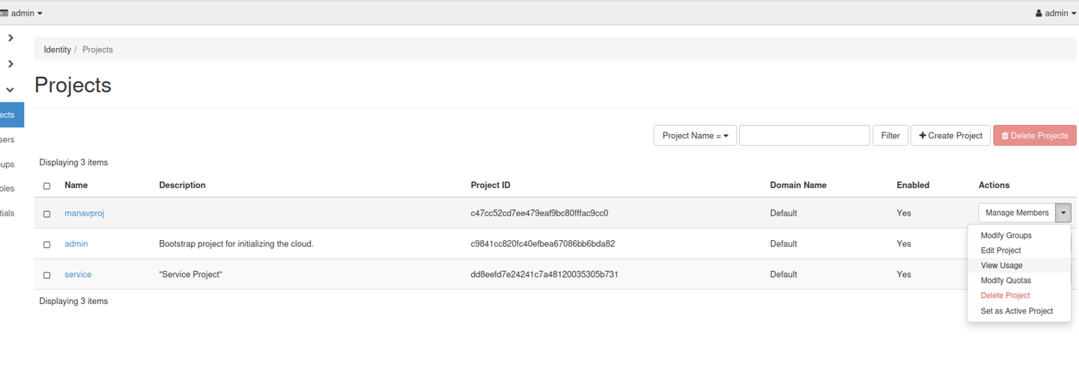

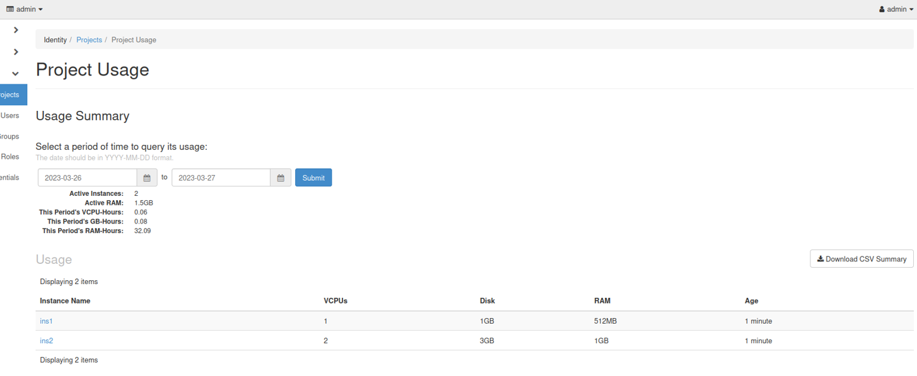

Step 9:- Download the CSV Summary

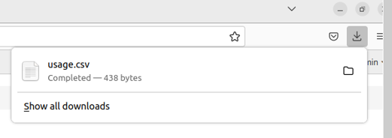

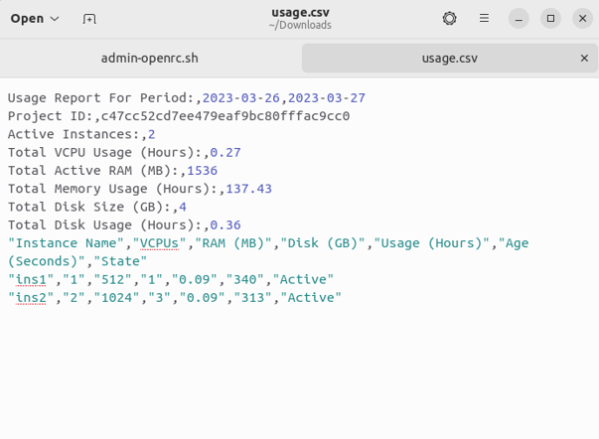

Step 10:- To modify quota goto admin proj-> projects -> modify quota

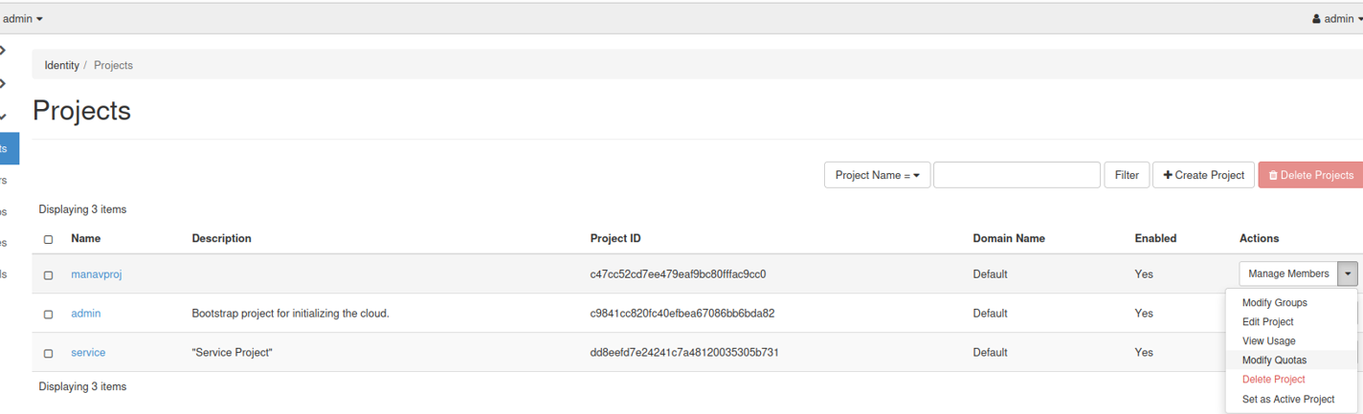

Step 11:- Edit the quota

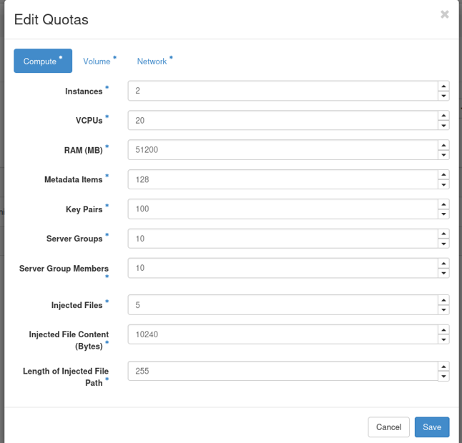

Step 12:- Goto target project to view the changes

